

Internal Audit – Research Computing

Process Understanding Document

Prepared by | Naema Al Marzooqi / Hatem Haddad
Date | January 2023

Research Computing

The Research Computing Department is responsible for ensuring the effective use of resources. All users of Research Computing (RC) resources are responsible for complying with the conditions of use of RC resources, as well as the applicable ICT acceptable use policies and guidelines. The Research Computing Committee (RCC) is responsible for making recommendations concerning resource allocation and priorities for RC resources. The KPIs for RC are set in accordance with their strategy and for the current year 2023 they are :

- Report departmental progress on a monthly basis
- Optimize utilization of HPC and RC resources
- Provide user Training
- Ensure user and faculty engagement
- Introduce a new service
- Conduct Research Computing Survey
- Ensure Research Computing Satisfaction
- Increase Visibility of RC at KU
- Partnerships with external entities
- Implement RC Expansion according to plan.

Organization Chart

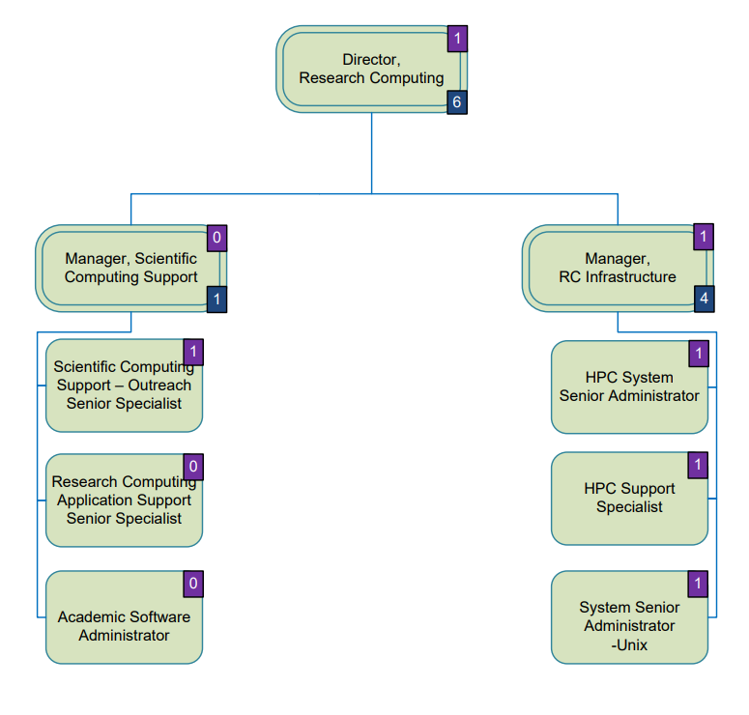

Following is the status of the positions:

Position
Director, Research Computing | Filled
HPC Support Specialist | Vacant
Manager, Scientific Computing Support | Filled
Manager, RC Infrastructure | Filled
System Senior Administrator-Unix | Filled
HPC System Senior Administrator | Vacant
Scientific Computing Support Senior Specialist | Vacant
Research Computing Support Senior Specialist | Vacant
Data Science Specialist | Vacant

RC Services
RC support researchers by understanding their research computational needs and by recommending suitable applications and other research computing resources available at the University. RC also assists researchers with grant proposals that have a strong High Performance Computing (HPC) component to describe the utilization of HPC resources in their research. They also ensure to resolve faculty and student computing resource issues and provide programming consultancy, code optimization and resolve users’ programming issues (based on Unix shell script, C/C++, Matlab, Python, MPI, OpenMP, CUDA). RC help build, install, maintain and test scientific applications on the HPC clusters. Morevoer, the department of RC develop awareness and training programs for students, faculty, and staff with regards to research computing techniques, services, and facilities, including HPC application training to help users parallelize, debug and optimize their applications along with conduct regular trainings workshops and tutorials, as well as one-on-one training for new users. Finally, RC perform required regular maintenance and upgrades in​ coordination with external vendors (Software) while hardware maintenance remains fully under Ankabut.

Use of RC Resources
All research computing facilities, including HPC systems, operated and maintained by the Department of Resource Computing RC is only be accessed by authorized users and are subject to KU’s policies on the appropriate use of Information Technology. All users utilizing the HPC or other research computing facilities, must acknowledge the use of facilities in their publications. Suitable text will be provided by RC and published and made available to users. Users are required to complete training courses before being given access to RC resources.
Research Computing Department currently provides access to a HPC cluster. HPC cluster is a set of computers (nodes) that can collaborate to solve computational problems. These can typically be used for running large memory jobs, jobs that require large computational power using multiple nodes or large amount of jobs that can be executed in parallel.
A short description of the HPC cluster is shown below:
Almesbar HPC cluster
Al Mesbar HPC cluster is in coordination with Ankabut where Ankabut provides support all the hardware between RC and vendors launched end of July 2021.
- Master nodes: for resource scheduling using Simple Linux Utility for Resource Management (SLURM).
- Submit nodes: 3 submit nodes for job submission from end-user computer using command line.
- Compute nodes: 131 Compute Nodes with a total of 6,812 CPU cores and a theoretical peak of performance of 597.8 TFLOPS. Out of these 131 nodes:
- 124 Nodes based on Intel Xeon Gold 6230R 26-Core 2.1GHz (Cascade Lake)(Q1‘20) processor.
- GPU nodes: 7 GPU (Graphic Processing Unit) nodes, 3 with 4 NVidia V100 GPU cards, and 4 with 2 NVidia V100 GPU cards, having a total of 20 GPUs and 102,440 CUDA GPU cores.
- Interconnectivity:
- Node-Switch interconnection uses Infiniband EDR network (100Gbps network speed).
- Switch-Switch interconnection uses Infiniband HDR network (200 Gbps network speed).
- Data Storage:
- 300 TB for home directories using NFSv4 at 10 Gbps.
- 947 TB for project directories using Parallel file system (Lustre)

Resources Allocation
RC resources are to be shared fairly by all users. This ensures that all users have access to a baseline level of service. Requests for additional resources are considered by the RC department and assessed by evaluating the need, the availability of resources and the impact on other users. This applies to all RC resources, whether this is storage, compute time or support. For demanding projects, it is normally possible to use project funds to purchase additional infrastructure/support for the project’s exclusive use, or alternatively share the additional resource as appropriate.

Scientific Computing Support
Scientific Computing Support is provided to users to aid in the effective provision and utilization of RC resources. The support provided will range from training, assisting researchers in running their codes on RC resources to providing consultation on performance analysis and code optimization.

Committees
The RC has the Research Computing Committee (RCC) and an approved charter is available on KU policy library with clear responsibilities. Nominations for the RCC are made by the Deans, with 2 faculty representative from each college. The members are then appointed by the SVP of R&D.

Reporting
RC reports to SVP R&D on monthly basis on the utilization of resources for all clusters identifies how much resources has been used, users, which research group is using them. RCC work has to be summarized and reported to University Research Council once a year.

Polices that apply to Research Computing
- R&D 4000 Research Governance.
- R&D 4700 Access Allocation and Use of Research Computing Resources.
- R&D 4710 Scientific Computing Support.
- ACA 8700 Academic Software Management

RC Budget 2021

Opex 2021
Account Description | Annual Budget | Revised Budget | Actual Amount | PR | PO | Fund Available
IT Systems & Support expenses | 2,142,692 | 1,023,910 | 1,018,910 | 0 | 0 | 5,000
Manpower supply | 0 | -865 | -866 |  |  | 1
Entertainment and hospitality | 8,583 | 0 |  |  |  | 0
Computer software licenses | 1,305,809 | 886,059 | 866,024 | 0 | 0 | 20,035
Business Travel - Combined expenses | 42,916 | 0 |  |  |  | 0
 | 3,500,000 | 1,909,104 | 1,884,068 | 0 | 0 | 25,036

Capex 2021
Account Description | Annual Budget | Revised Budget | Actual Amount | PR | PO | Fund Available
Laboratory equipment | 1,950,000 | 5,546,000 | 5,545,455 | 0 | 0 | 545
 | 1,950,000 | 5,546,000 | 5,545,455 | 0 | 0 | 545

RC Budget 2022

Opex 2022
Account Description | Annual Budget | Revised Budget | Actual Amount | PR | PO | Fund Available
IT Systems & Support expenses | 1,100,000 | 800,000 |  | 798,441 |  | 1,559
Computer software licenses | 1,015,642 | 1,315,642 | 15,326 | 728,247 | 571,375 | 693
 | 2,115,642 | 2,115,642 | 15,326 | 1,526,688 | 571,375 | 2,252

Capex 2022
Account Description | Annual Budget | Revised Budget | Actual Amount | PR | PO | Fund Available
Hardware & peripherals | 10,000 | 10,000 | 9,510 | 0 | 0 | 490
Laboratory equipment | 6,595,858 | 6,595,858 |  | 6,593,486 |  | 2,372
Computer software | 190,000 | 190,000 | 33,644 | 142,163 | 0 | 14,193
 | 6,795,858 | 6,795,858 | 43,154 | 6,735,649 | 0 | 17,055

Other Matters
- Backups of Data are conducted by Ankabut and not by RC.
- Maintenance of SW is conducted by vendors as a part of buying the HW.

Challenges:

- Lack of manpower – HR process.
- Licenses expire due to long procurement process.
- Overlap of legacy licenses.

